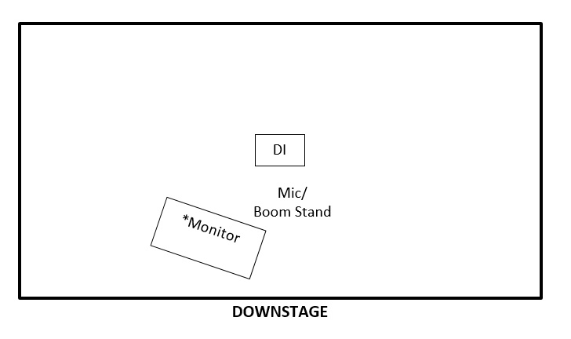

INPUT LIST
One (1) VOCAL MIC (SM58 preferred)
One (1) boom stand/XLR cable
One (1) DI-BOX for acoustic guitar
**Channels are at the sound tech’s discretion

MONITORS
One or two wedge floor monitors. *If available
ON-STAGE EQUIPMENT
One short, flat-top stool (24”)—not a bar stool Two guitar stands

